

LEVERAGING LOCAL LLM’s TO BENEFIT PC USERS AND FINE-TUNE PCs FOR PROFFESSIONAL WORKERS
A PROJECT REPORT
Submitted by
Dilip Kumar.G [ 313522205010]
Kishore.B [ 313522205030]
Mohan.M [ 313522205036]
D.Muthu Karthickeyan [ 313522205038]
in partial fulfillment for the award of the degree
of
BACHELOR OF TECHNOLOGY
IN
INFORMATION TECHNOLOGY

PANIMALAR ENGINEERING COLLEGE CHENNAI CITY CAMPUS
CHENNAI-600030.
ANNA UNIVERSITY: CHENNAI 600 025

LEVERAGING LOCAL LLM’s TO BENEFIT PC USERS AND FINE-TUNE PCs FOR PROFFESSIONAL WORKERS

A PROJECT REPORT
Submitted by
Dilip Kumar.G [313522205010]
Kishore.B [313522205030]
Mohan.M [313522205036]
D.Muthu Karthickeyan [313522205038]
in partial fulfillment for the award of the degree
of
BACHELOR OF TECHNOLOGY IN
INFORMATION TECHNOLOGY

PANIMALAR ENGINEERING COLLEGE CHENNAI CITY CAMPUS
CHENNAI-600030.
ANNA UNIVERSITY: CHENNAI 600 025
BONAFIDE CERTIFICATE
Certified that this project report “LEVERAGING LOCAL LLM’s TO BENEFIT PC USERS AND FINE-TUNE PCs FOR PROFFESSIONAL WORKERS” is the bonafide work of Dilip Kumar.G[313522205010], Kishore.B[313522205030], Mohan.M[313522205036] and D.Muthu Karthickeyan[313522205038], who carried out the project work under my supervision.

SIGNATURE SIGNATURE

Dr.S.KANIMOZHI .,M.E.,Ph.D., Dr.S.KANIMOZHI .,M.E.,Ph.D., HEAD OF THE DEPARTMENT SUPERVISOR

HEAD OF THE DEPARTMENT
DEPARTMENT OF IT, DEPARTMENT OF IT,
PANIMALAR ENGINEERING COLLEGE, PANIMALAR ENGINEERING COLLEGE, CHENNAI CITY CAMPUS, CHENNAI CITY CAMPUS,
NUNGAMBAKKAM, NUNGAMBAKKAM,
CHENNAI-600 030. CHENNAI-600 030.

Certified that the above candidate(s) was/ were examined in the Anna University Project Viva-Voce Examination held on : __/__/2026.

INTERNAL EXAMINER EXTERNAL EXAMINER

DECLARATION BY THE STUDENT
We DilipKumar.G[313522205010],Kishore.B[313522205030], Mohan,M[313522205036], D.Muthu Karthickeyan[313522205038] hereby declare that this project report titled “LEVERAGING LOCAL LLM’s TO BENEFIT PC USERS AND FINE-TUNE PCs FOR PROFFESSIONAL WORKERS”, under the guidance of Dr.S.KANIMOZHI, M.E., Ph.D., is the original work done by us and we have not plagiarized or submitted to any other degree in any university by us.

ACKNOWLEDGEMENT
We would like to express our deep gratitude to our respected Secretary and Correspondent Dr.P.CHINNADURAI, M.A., Ph.D. for his kind words and enthusiastic motivation, which
inspired us a lot in completing this project.

We express our sincere thanks to our Directors Tmt.C.VIJAYARAJESWARI, Dr.C.SAKTHI KUMAR,M.E.,Ph.D and Dr.SARANYASREE SAKTHI
KUMAR B.E.,M.B.A.,Ph.D., for providing us with the necessary facilities to undertake this project.

We also express our gratitude to our Principal Dr.S.MURUGAVALLI, M.E., Ph.D. who facilitated us in completing the project.

We thank the Head of the IT Department, Dr.S.KANIMOZHI, M.E.,Ph.D.,
for the support extended throughout the project.

We would like to thank my Project Guide Dr.S.KANIMOZHI, M.E.,Ph.D., and all the faculty members of the Department of CSE for their advice and encouragement for the successful completion of the project.

ABSTRACT

Modern organizations require secure and efficient project management systems that support structured access control and intelligent assistance. This project presents a role-based project management system integrated with an AI assistant to improve organizational productivity and workflow efficiency. The system defines four hierarchical roles—CEO, Manager, Project Lead, and Employee—with clearly enforced Role-Based Access Control (RBAC). The CEO manages departments and users, Managers handle departments, users, and projects, Project Leads assign tasks and upload documents, and Employees update task status and access documents. All roles are provided controlled access to AI features for intelligent query handling, task support, and information assistance. The AI component functions as a productivity aid without violating access restrictions or organizational policies. The system is designed using a modular architecture to ensure scalability, security, and maintainability. The proposed approach demonstrates how integrating RBAC with AI-driven assistance enhances collaboration, accountability, and operational efficiency in enterprise environments.

 | LIST OF FIGURES:
FIGURE NO. | TITLE | PAGE NO.
1
2
3
4
5
6
7

8

TABLE OF CONTENTS

CHAPTER NO. | TITLE | PAGE NO.
 | ABSTRACT | iii
 | LIST OF FIGURES | iv  v
  LIST OF SYMBOLS AND ABBREVIATIONS | Iv
1. | INTRODUCTION | 1-3
 | 1.1 Overview
 | 1.2 Problem Definition
2. | LITERATURE SURVEY | 4-8
3. | SYSTEM ANALYSIS | 9-15
 | 3.1 Existing System
  - Proposed System
  - Feasibility System
  - Dataset Description

  - Hardware Environment
  - Software Environment

CHAPTER NO. TITLE PAGE NO.

16-26

SYSTEM DESIGN
  - Data Flow Diagram
  - Sequence Diagram

  - Class Diagram
  - Use case Diagram
  - Dataset Graphical representation

PROPOSED METHODOLOGY 27-32
  - Architecture Overview
  - Algorithms

SYSTEM IMPLEMENTATION 33-38
  - Coding
  - Coding Layout

CHAPTER NO. | TITLE | PAGE NO.
7. | SYSTEM TESTING  7.1 Test Cases | 39-41
8. | CONCLUSION | 42-43
 | 8.1 Conclusion
 | 8.2 Future Enhancements
 | APPENDICES | 44-45
 | A.1 Sample Screens
 | REFERENCES | 46

CHAPTER 1
INTRODUCTION

With the increasing complexity of organizational workflows, effective project and task management has become essential for maintaining productivity, accountability, and operational efficiency. Traditional project management systems often rely on manual coordination and lack structured access control, leading to security risks and inefficient resource utilization. Additionally, most existing systems provide limited intelligent assistance to users during task execution and decision-making.
The advancement of Artificial Intelligence (AI) has enabled the development of intelligent systems that can assist users by providing contextual information, summaries, and productivity support. However, integrating AI into enterprise applications requires careful control to ensure security, privacy, and role-based access compliance. Role-Based Access Control (RBAC) is widely adopted in modern software systems to restrict access based on user responsibilities and organizational hierarchy.
This project focuses on the design and implementation of a role-based project management system integrated with AI assistance, suitable for organizational environments. The system supports four hierarchical roles—CEO, Manager, Project Lead, and Employee—each with predefined permissions. By combining RBAC with AI-enabled support, the system aims to improve workflow efficiency, enhance collaboration, and provide a secure and scalable solution for modern enterprises.

Overview

The proposed system is a centralized web-based application designed to manage organizational departments, projects, tasks, and documents through a structured role-based framework. Users interact with the system based on their assigned roles, ensuring controlled access to functionalities and data.

The CEO is responsible for managing departments and users at the organizational level. Managers oversee departments, users, and projects, enabling operational planning and supervision. Project Leads assign tasks to employees and upload project-related documents. Employees focus on task execution by updating task status and accessing relevant documents. All users have access to an integrated AI assistant that provides intelligent support such as answering queries, summarizing information, and assisting with task-related activities.

The system follows a modular architecture consisting of user management, project management, task handling, document management, and AI assistance modules. Role-based access validation is enforced at every level to ensure security, accountability, and data integrity. The overall design emphasizes scalability, usability, and efficient workflow management

Problem Definition

Organizations increasingly rely on digital systems to manage departments, projects, tasks, and documentation. However, many existing project management solutions lack structured role-based control and integrated intelligence, resulting in inefficient workflows, security vulnerabilities, and limited decision support. Users often experience unclear access boundaries, manual task tracking, and information overload, which negatively impact productivity and accountability.

Additionally, while Artificial Intelligence (AI) has shown potential in improving productivity through automation and intelligent assistance, its integration into enterprise systems is often unregulated or role-agnostic. This can lead to unauthorized data access, inconsistent usage, and reduced trust in AI-driven outputs. Therefore, there is a need for a system that combines strict Role-Based Access Control (RBAC) with controlled AI-assisted functionality, ensuring that users receive intelligent support without violating organizational hierarchy or security policies.

The problem addressed by this project is the design and implementation of a secure, role-based project management system with integrated AI assistance, capable of supporting organizational workflows while maintaining access control, accountability, and scalability.

Role-Based Access Enforcement
Ensuring that each user accesses only the functionalities permitted by their role is a critical challenge. Improper enforcement of access control can lead to unauthorized operations, data exposure, and security vulnerabilities within the system.
AI Integration with Access Control
While AI enhances productivity, integrating it into a role-based system requires strict regulation. The challenge lies in providing AI assistance to all users without allowing the AI to bypass role restrictions or expose sensitive information.

Task and Document Management
Managing tasks and documents across multiple projects and users introduces complexity in maintaining data consistency, ownership, and controlled access. Unauthorized updates or document access can compromise project integrity.
Scalability and Maintainability
As the number of users, projects, and tasks increases, the system must handle higher workloads efficiently. Poor architectural decisions can lead to performance degradation and difficulties in maintaining or extending the system.
Data Security and Integrity
Protecting organizational data from unauthorized access, accidental loss, or inconsistency is a continuous challenge in multi-user systems, especially when shared resources are involved.

Potential solutions:
Implementation of Role-Based Access Control
Role-Based Access Control ensures that all system functionalities are accessible only to authorized users. Every request is validated against predefined permissions, reducing the risk of unauthorized actions.
Controlled AI Assistance
The AI component is implemented as an assistive tool that operates within the context of the user’s role. AI responses are restricted to authorized data, ensuring compliance with organizational access policies.
Modular System Architecture
The system is designed using a modular architecture, separating user management, project management, task handling, document management, and AI assistance. This improves scalability, maintainability, and fault isolation.
Secure Data Management Practices
Authentication, authorization, and data validation mechanisms are employed to ensure data confidentiality and integrity throughout the system lifecycle.

Scalable Design Approach
The architecture supports future expansion by allowing new features, additional roles, and increased workloads to be integrated without significant changes to the existing system.

CHAPTER 2
LITERATURE REVIEW

Article Title & Author(s) Name | Journal Name/Year | Problem Addressed/Identified | Research Contribution/Novelty | Algorithm/Technique Used | Findings/ Outcomes | Limitations/  (Areas of Improvement/Future Direction)
The Programmer’s Assistant: Conversational Interaction with a Large Language Model for Software Development — Steven I. Ross, Fernando Martinez, Stephanie Houde, Michael Muller, Justin D. Weisz. | arXiv / 2023 | Traditional code-assistant UIs invoke LLMs statelessly and expose limited functionality; lack of multi-turn, context-aware conversational interaction grounded in code. | Prototype demonstrating multi-turn conversational interactions grounded in code; studies users’ receptiveness and productivity impacts. | LLM-based multi-turn conversational system; evaluation with 42 participants. | Conversational grounding enabled richer assistance (explanations, debugging, multi-step tasks). | Small-scale study; hallucination and privacy concerns; needs IDE integration.
A Systematic Survey of Prompt Engineering in Large Language Models: Techniques and Applications — Pranab Sahoo, Ayush K. Singh, Sriparna Saha, Vinija Jain, Samrat Mondal, Aman Chadha. | arXiv / 2024 | Lack of structured taxonomy for prompt-engineering techniques and applications. | Provides taxonomy and categorization of prompting techniques and identifies research gaps. | Survey and taxonomy diagrams (meta-analysis). | Clarifies best-use cases and research gaps in evaluation and robustness. | Field evolving rapidly; needs standardized benchmarks and robustness metrics.
Generative AI for Software Practitioners — Christof Ebert, Panos Louridas, et al. | IEEE Software / 2023 | Understanding how generative AI affects software engineering practice. | Describes technology, use cases, risks, and adoption guidance for practitioners. | Conceptual discussion and case examples. | Argues generative AI reshapes software roles and offers adoption recommendations. | Lacks empirical validation; calls for longitudinal studies and benchmarking.
Natural Language Generation and Understanding of Big Code for AI-Assisted Programming: A Review — Man Fai Wong, Shangxin Guo, Ching Nam Hang, Siu Wai Ho, Chee Wei Tan. | Entropy (MDPI) / 2023 | Need for a comprehensive review of NLP techniques trained on Big Code and their use in AI-assisted programming tasks. | Comprehensive review covering transformer-based LLMs for code tasks (generation, completion, translation, summarization) and analysis of datasets/metrics. | Survey of models, datasets, and evaluation metrics used in Big Code research. | Summarizes state-of-the-art models and applications and highlights challenges. | Rapidly changing field; needs better evaluation metrics, robustness, and security/privacy measures.
Large Language Models for Software Engineering: Survey and Open Problems — Angela Fan, Beliz Gokkaya, Mark Harman, Mitya Lyubarskiy, Shubho Sengupta, Shin Yoo, Jie M. Zhang. | IEEE/ACM (workshop) / 2023 | Applying LLMs to concrete software-engineering problems and addressing challenges like hallucination and reliability. | Survey identifying application areas across SE and articulating open research challenges and hybrid approaches. | Literature synthesis and discussion of hybrid LLM + classical SE methods. | Emphasizes emergent properties of LLMs, potential benefits, and need for hybrid systems for correctness and trustworthiness. | Many open questions: reliable verification, SE-specific benchmarks, and human-AI collaboration studies.
Leveraging Indoor Localization Data: The Transactional Area Network (TAN) — Anastasios Nikolakopoulos, Alexandros Psychas, Antonios Litke, Theodora Varvarigou. | Electronics (MDPI) / 2024 | How to exploit indoor localization data to enable new location-aware transactional services and analytics. | Proposes the Transactional Area Network (TAN) framework to represent and analyze indoor localization events for transactional/analytic applications. | System design and algorithms for processing indoor localization streams; evaluation on collected/simulated indoor data. | Demonstrates TAN’s utility for deriving transactional areas and enabling analytics for retail and smart buildings. | Needs real-world deployment validation, privacy-preserving mechanisms, and evaluation on diverse venues.
Learning to Generate Pseudo-code from Source Code using Statistical Machine Translation — Yusuke Oda, Hiroyuki Fudaba, et al. | ASE / 2015 | Automating the generation of human-readable pseudo-code from source code to help comprehension. | Introduces an SMT-based framework mapping source code to pseudo-code (line-to-line translation). | Statistical Machine Translation techniques adapted to code→pseudo-code translation; trained on aligned corpora. | Shows SMT can produce useful pseudo-code and reduce reading effort; demonstrates feasibility of treating code→NL as translation. | SMT methods limited compared to modern neural approaches; needs larger aligned corpora and transformer-based models.
Exploring the Potential of Offline LLMs in Data Science: A Study on Code Generation for Data Analysis — Anastasios Nikolakopoulos, Antonios Litke, Alexandros Psychas, Theodora Varvarigou. | IEEE Access / 2025 | Investigating the feasibility and utility of running LLM-based code generation offline (local models) for data-analysis tasks. | Empirical study exploring offline/local LLMs for generating data-analysis code; discusses model selection, performance, privacy, and latency tradeoffs. | Experiments with offline-hosted LLMs to generate code for common data-analysis workflows; evaluated for correctness and usability. | Shows offline LLMs can be useful for many data-analysis tasks while offering privacy and latency benefits; highlights tradeoffs in model size and configuration. | Practical limitations: compute/resource constraints, lower performance than cloud models on complex tasks, and the need for frequent updates.
Leveraging Pre-trained Language Models for Code Generation — Ahmed Soliman, M. Hadhoud, S. Shaheen, et al. | Complex & Intelligent Systems / 2024 | How to design hybrid approaches that use pre-trained NLP transformers to improve code-generation accuracy and efficiency. | Proposes hybrid models leveraging pre-trained encoders with Marian-style decoders for improved seq2seq code generation. | Hybrid transformer architectures (pre-trained encoders + Marian decoder); experiments on CoNaLa and DJANGO datasets. | Achieves competitive accuracy on benchmark datasets; demonstrates benefits of encoder-decoder synergy. | Limited to certain datasets and languages; modern code-specialized models may outperform—suggests scaling/adapting to larger models.
Shortcut Learning Explanations for Deep Natural Language Processing: A Survey on Dataset Biases — Varun Dogra, Sahil Verma, Kavita, Marcin Wozniak, Jana Shafi. | IEEE Access / 2024 | Dataset-induced shortcut learning (models pick spurious cues) in deep NLP and the need for systematic explanations/mitigations. | Survey cataloging dataset biases leading to shortcut learning, reviews explanation techniques and mitigation strategies, and suggests best practices. | Survey of shortcut/bias detection and explanation methods (probing, counterfactuals, adversarial examples). | Summarizes bias types and mitigation approaches; stresses gap between accuracy and true generalization. | Future work: standardized benchmarks for shortcut detection, causal/explainable approaches, and integration of mitigation into training.

CHAPTER 3

SYSTEM ANALYSIS

Data collection and preprocessing:
The proposed system requires structured data related to users, departments, projects, tasks, and documents. Data is collected through user inputs during system operations such as user creation, project assignment, task updates, and document uploads. Each data entry is validated to ensure correctness, completeness, and consistency before being stored in the database.
Preprocessing involves organizing the collected data into structured formats suitable for efficient retrieval and processing. This includes removing redundant entries, validating role permissions, and maintaining referential integrity between entities such as users, projects, and tasks. Proper preprocessing ensures reliable system performance and accurate AI-assisted responses.
Model deployment:
The AI component is deployed as an integrated service within the system architecture. It is accessible to all users irrespective of their role, while still adhering to role-based access control policies. The model processes user queries and provides intelligent assistance such as information retrieval, summaries, and task-related guidance.
The AI model operates as a supportive tool and does not perform any autonomous actions. All AI-generated responses are filtered based on user permissions to prevent unauthorized access to sensitive data. This controlled deployment ensures secure and efficient AI utilization within the system.

EXISTING SYSTEM
In the existing system, project and task management is often handled using manual methods or basic digital tools such as spreadsheets, emails, or standalone applications. These approaches lack centralized control, leading to data inconsistency, limited collaboration, and difficulty in tracking task progress.

Existing systems also provide minimal access control, where users may have excessive or unclear permissions. Additionally, there is little to no integration of intelligent assistance, resulting in increased manual effort for decision-making and reporting.

PROPOSED SYSTEM
The proposed system introduces a centralized, role-based project management platform integrated with AI assistance. The system defines four roles—CEO, Manager, Project Lead, and Employee—each with clearly defined permissions.

The CEO manages departments and users, ensuring organizational governance. Managers manage departments, users, and projects. Project Leads assign tasks and upload documents, while Employees update task statuses and view assigned documents. All users have access to AI features that assist with information retrieval, summaries, and productivity support.

The system enforces Role-Based Access Control at every level, ensuring security, accountability, and efficient workflow management.

FEASIBILITY SYSTEM

Technical Feasibility
The system is technically feasible as it is developed using widely supported programming languages, frameworks, and databases. The integration of AI is achieved using existing libraries and APIs, making implementation practical and reliable.

Operational Feasibility
The system is easy to use and aligns with standard organizational workflows. Minimal training is required for users to adapt to the system, making it operationally feasible.

Economic Feasibility
The project is cost-effective as it relies on open-source tools and does not require expensive infrastructure. This makes it suitable for academic implementation and small to medium-scale organizations.

DATA DICTIONARY

Layer | Technology | Purpose
UI | React | Interface
UI | Tailwind | Styling
UI | shadcn | Components
UI | Axios | API calls
Server | Node | Runtime
Server | Express | REST APIs
DB | MongoDB | Storage
DB | Mongoose | Models
Auth | JWT | Login security
Auth | bcrypt | Password hashing
AI | Ollama | Offline AI
Core | CRUD Engine | Data access
Core | Policy Engine | Permissions

Table 1: Data Dictionary

Hardware Environment

The proposed Role-Based Project Management System is a centralized web-based application developed using the MERN stack with an integrated local AI assistant. The system follows a client–server architecture where users access the platform through web browsers, while the backend server processes requests, manages the database, enforces role-based access control, and interacts with the AI engine.
The hardware environment is designed to support secure operations, concurrent multi-user access, and scalable AI-assisted processing. The system can operate on standard computing devices for clients and requires moderate server resources for backend services and AI inference.

Component | Minimum Requirement | Recommended Requirement | Purpose
Processor | Quad Core 2.0 GHz | 8–16 Core CPU | API handling + AI inference
RAM | 8 GB | 16–32 GB | Node.js server, MongoDB caching, Ollama models
Storage | 50 GB SSD | 200+ GB SSD | Database + documents + AI models
GPU | Not mandatory | NVIDIA GPU (6–12GB VRAM) | Faster AI responses
Network | 10 Mbps | 100 Mbps–1 Gbps | Multi-user traffic
Client Devices | Any modern PC/mobile | Desktop/Laptop preferred | System access
Display | 1366×768 | 1920×1080 | Dashboard usability

Software Environment

The proposed Role-Based Project Management System is developed using modern full-stack web technologies based on the MERN architecture. The software environment consists of client-side frameworks for interactive user interfaces, backend technologies for API and business logic processing, database systems for persistent storage, security libraries for authentication and authorization, and an AI runtime for intelligent assistance.
The environment ensures scalability, maintainability, performance, and secure operations across all organizational levels.

Layer | Technology | Purpose
Frontend | React | User Interface (SPA)
Styling | Tailwind CSS | UI styling & layouts
UI Components | shadcn/ui | Professional reusable components
API Client | Axios | Backend communication
Backend Runtime | Node.js | Server execution environment
Web Framework | Express.js | REST API development
Database | MongoDB | Persistent storage
ODM | Mongoose | Schema & DB abstraction
Authentication | JWT | Stateless authentication
Security | bcryptjs | Password hashing
AI Engine | Ollama | Local LLM assistant
Version Control | Git/GitHub | Source management

CHAPTER 4

SYSTEM DESIGN

Data Flow Diagram

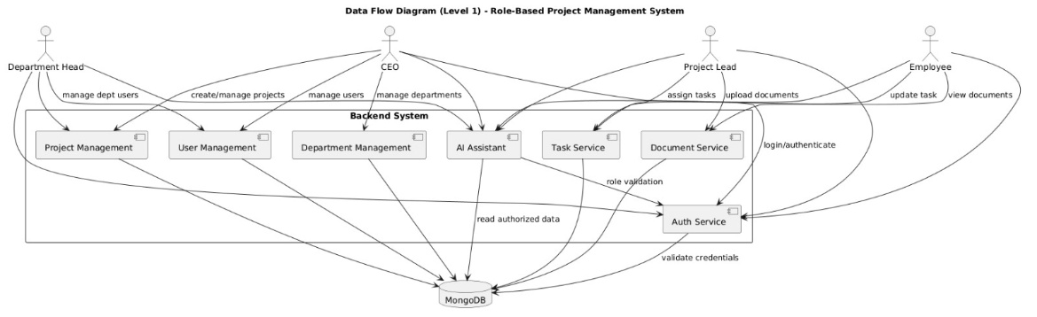

Figure 1: Data Flow Diagram

Sequence Diagram

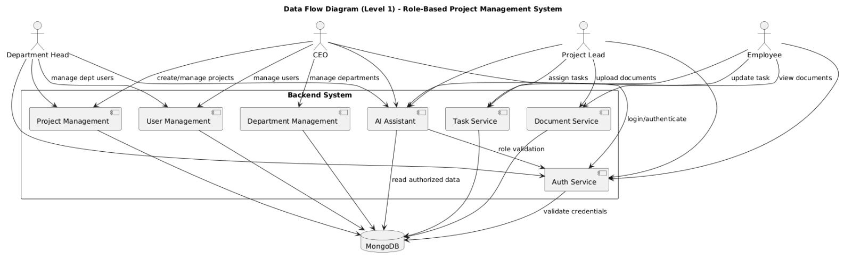

Figure 2: Sequence Diagram

Class Diagram

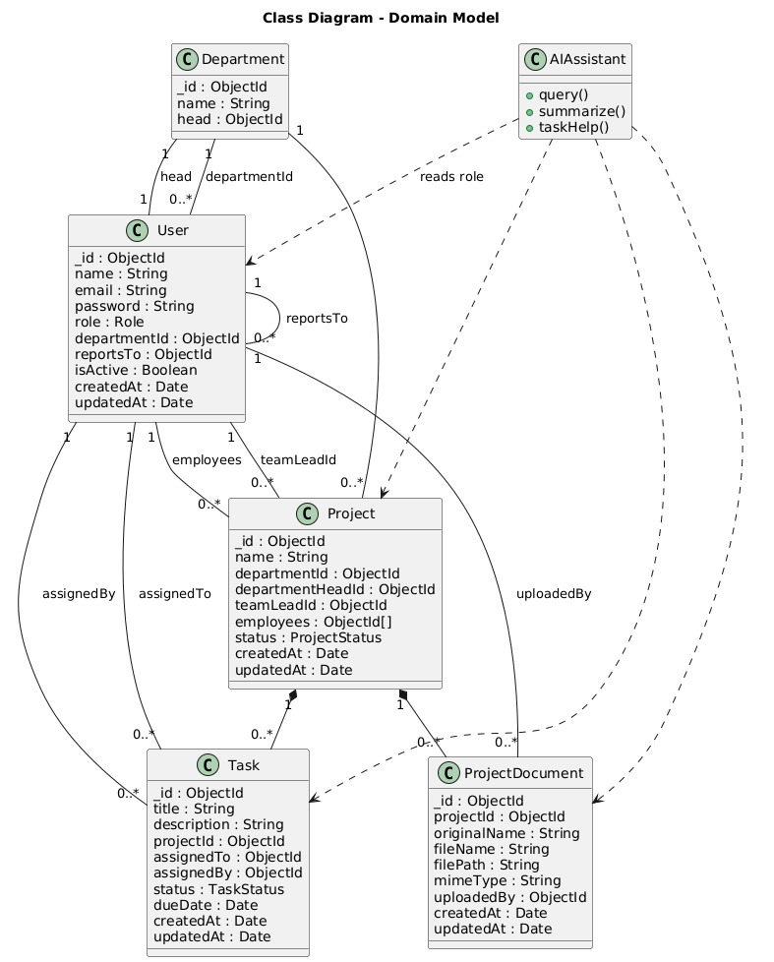
Figure 3: Class Diagram

Usecase Diagram

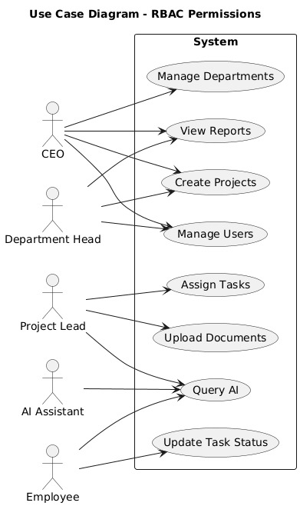

Figure 4: Usecase Diagram

Dataset graphical representation

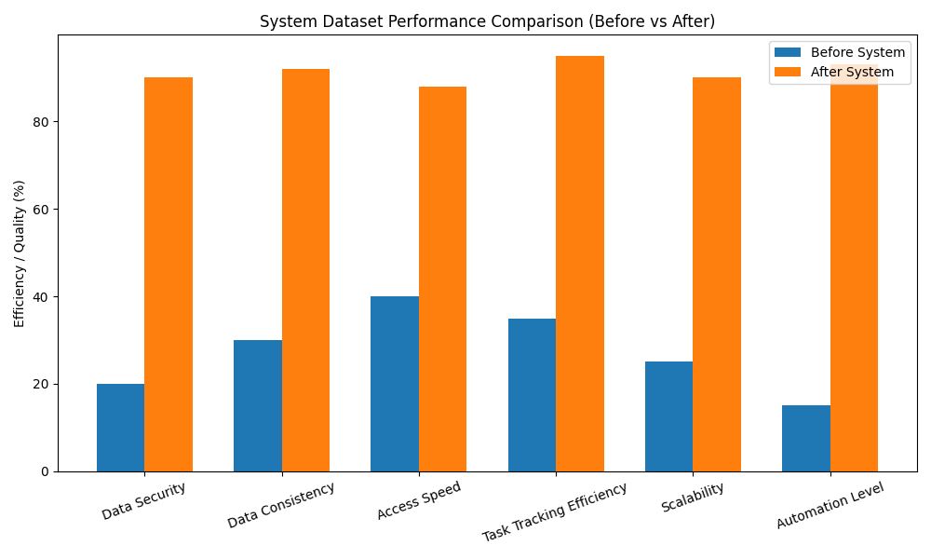

Figure 5: Dataset Graphical Representation

CHAPTER 5

PROPOSED ARCHITECTURE

Architecture Overview

The system architecture is designed to support a role-based project management platform integrated with AI assistance. The architecture follows a modular and layered approach to ensure scalability, security, and maintainability. Each system component is responsible for a specific functionality, and communication between components is controlled through well-defined interfaces.

The presentation layer provides user interaction through a web-based interface, allowing users to perform actions based on their assigned roles. The application layer handles business logic, including role validation, project management, task assignment, and document handling. Role-Based Access Control is enforced at this layer to ensure that users can access only authorized functionalities.

The AI integration layer provides intelligent assistance to all users by processing queries and generating contextual responses. The AI component operates independently of core system operations and does not modify system data. The data layer manages persistent storage of users, departments, projects, tasks, and documents, ensuring data consistency and integrity.

This architecture enables efficient workflow management while maintaining strict access control and secure AI integration.
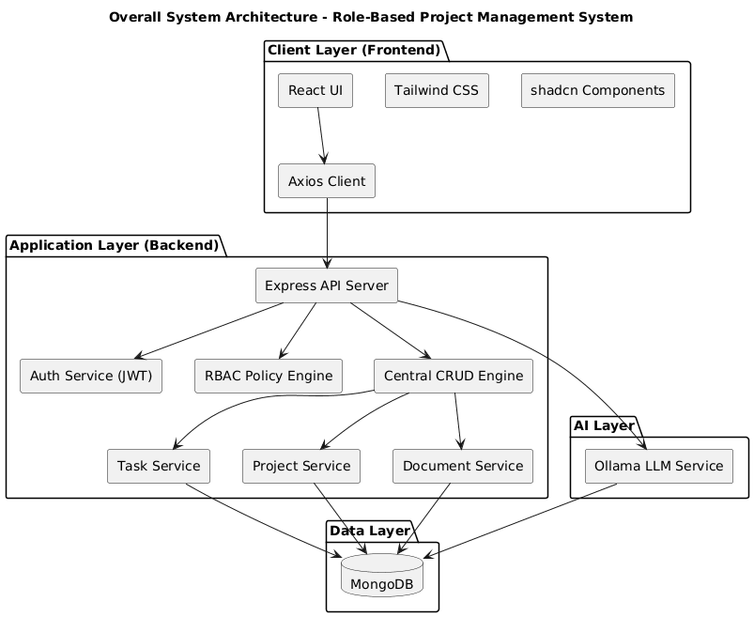

Architecture Diagram

Algorithms

User Authentication and Role Validation Algorithm

When a user attempts to access the system, authentication is performed using valid credentials. After successful authentication, the system retrieves the user’s role and validates access permissions for each requested operation. If the role is authorized, the request is processed; otherwise, access is denied.

Project and Task Management Algorithm

Managers create and manage projects by assigning Project Leads. Project Leads assign tasks to Employees, and Employees update task status. Each operation is validated against role permissions to ensure proper access control. Task updates are stored and reflected in real-time.

Document Management Algorithm

Project Leads upload project-related documents, which are stored securely in the system. Employees can view documents based on project association. Role-based checks ensure that unauthorized users cannot access or modify documents.

AI Assistance Algorithm

User queries are sent to the AI module along with role context. The AI processes the query and generates a response relevant to the user’s permissions. The response is filtered to prevent access to restricted information before being returned to the user.

Access Control Enforcement Algorithm

Every system request passes through a permission validation process. The system maps the user’s role to allowed actions and verifies authorization before executing the requested operation.

